Social Media Based Diary Method
Extract from Christian Vegan WhatsApp Group
Full resource: https://www.ncrm.ac.uk/resources/online/all/?id=20838

(All names are pseudonyms.)
20 July 2021
Michelle - 20:22 - Quick dinner after my youngest sons football training 🥵. Not something I'd usually buy, but my youngest needed Fishless Fingers for Cub camp last weekend. I don't tend to like "fake" things and certainly not anything fishy, but these were ok and made a great fast meal on a hot day.
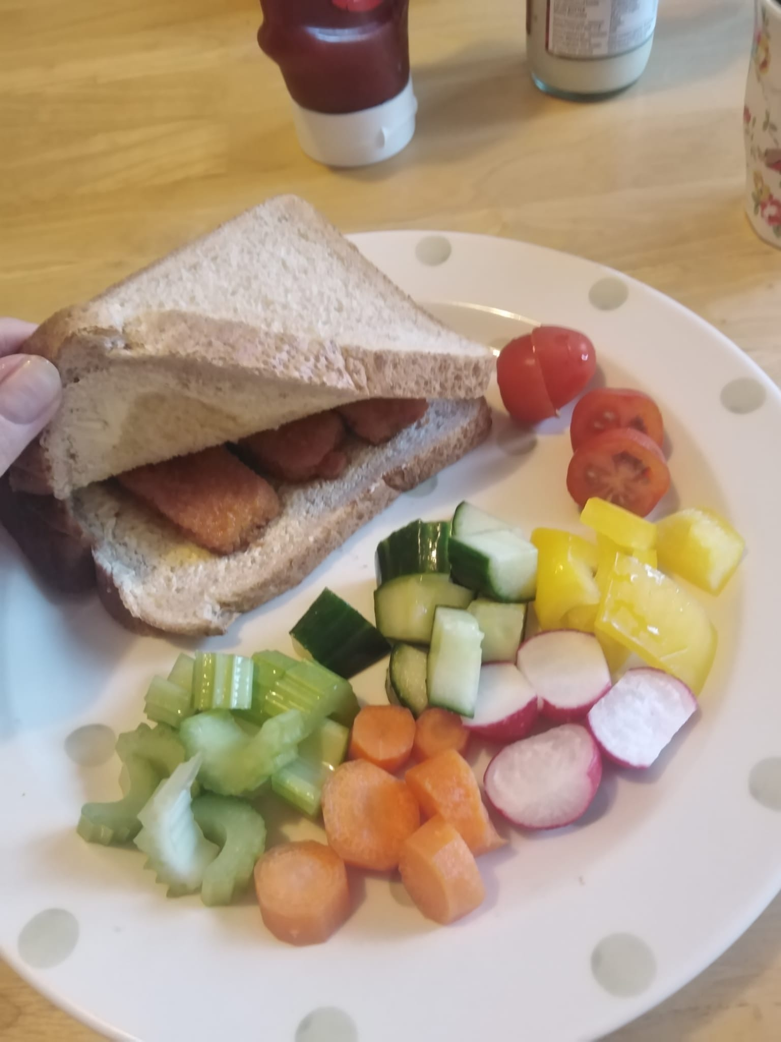
Michelle - 20:23 - I haven't seen this brand before, my neighbour found them in Sainsburys I think.
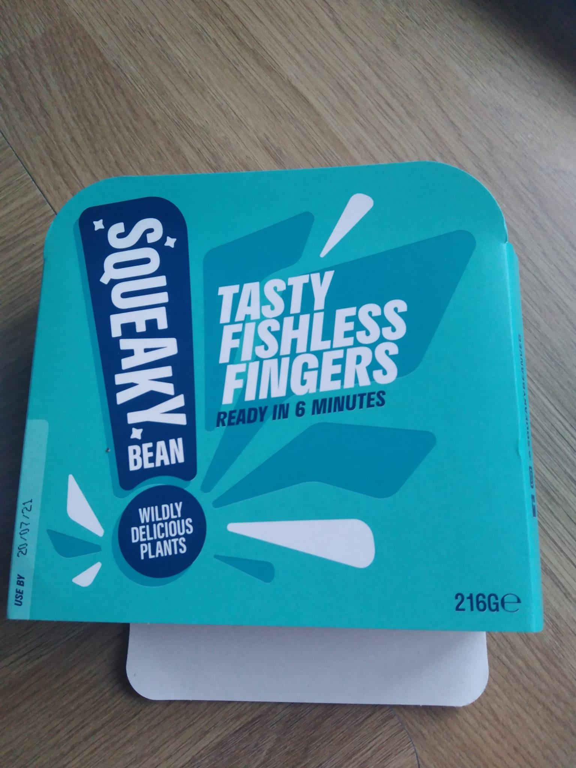
Malcolm - 20:24 - Replying to Michelle: “I haven't seen this brand before, …”
Sainsbury’s and Asda do this brand. They do nuggets and also do thinks like fake meat chunks in different sauces
Beth - 20:27 - I actually like the quorn vegan fishless fingers - haven’t had them in ages as trying to eat clean but now I’m craving a fishless finger sandwich
Malcolm - 20:28 - I was a meat and 2 veg man before my conversion so I do appreciate the meat substitutes.
Beth - 20:37 - Replying to Malcolm: “I was a meat and 2 veg man before my conversion…”
I like meat substitutes. I’m vegan for ethical reasons. I’ve been trying to eat clean as I’ve been seeing a nutritionist and found out I’m gluten intolerant and a lot have wheat protein in them.
Malcolm - 20:39 - Replying to Beth: “I like meat substitutes. I’m vegan for ethical reasons. …”
Yes me too. I’m an ethical vegan. I like the substitutes but I know they’re not the most healthy. Been cooking a lot myself using mushrooms as much of the substitute. Using Bosh and dirty vegan a lot
Louis - 20:41 - Substitutes make us hyper now that we are eating clean. I like them for a protein boost now and then but we never feel better the evening or the morning after. They are however easy to come by in LDN and surroundings
Nicola - 21:03 - We eat like old people but it works for us... Bigger meal at midday and soup for dinner. Tonight is fennel and lemon.
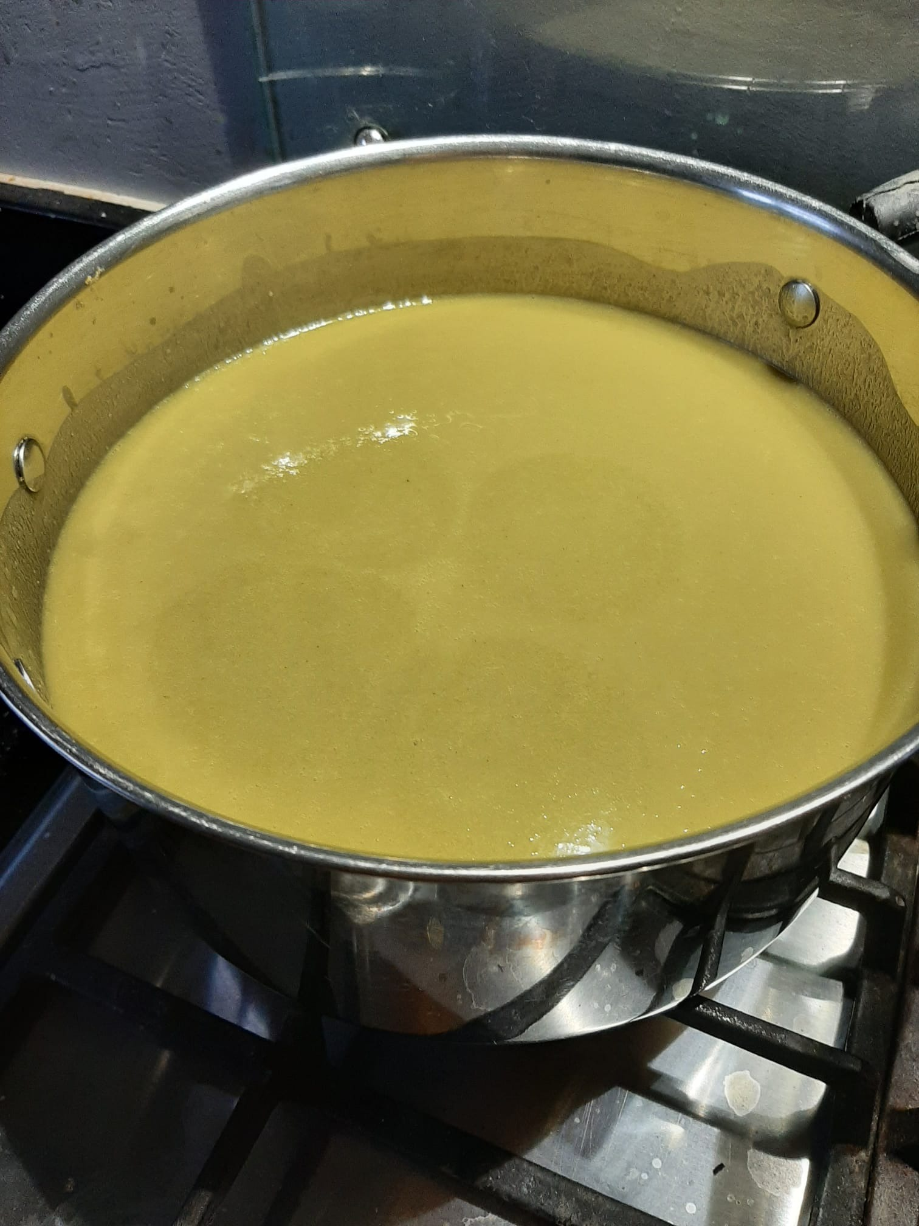
Malcolm - 21:03 - Replying to Nicola: “We eat like old people but it works for us...”
That’s what my folks do 😃
Nicola - 21:05 - I have also made my stock for the week... Again, I just didn't think the house was quite warm enough today. Had to help it along with a steaming pot of stock! 🤣🤷‍♀️🥵
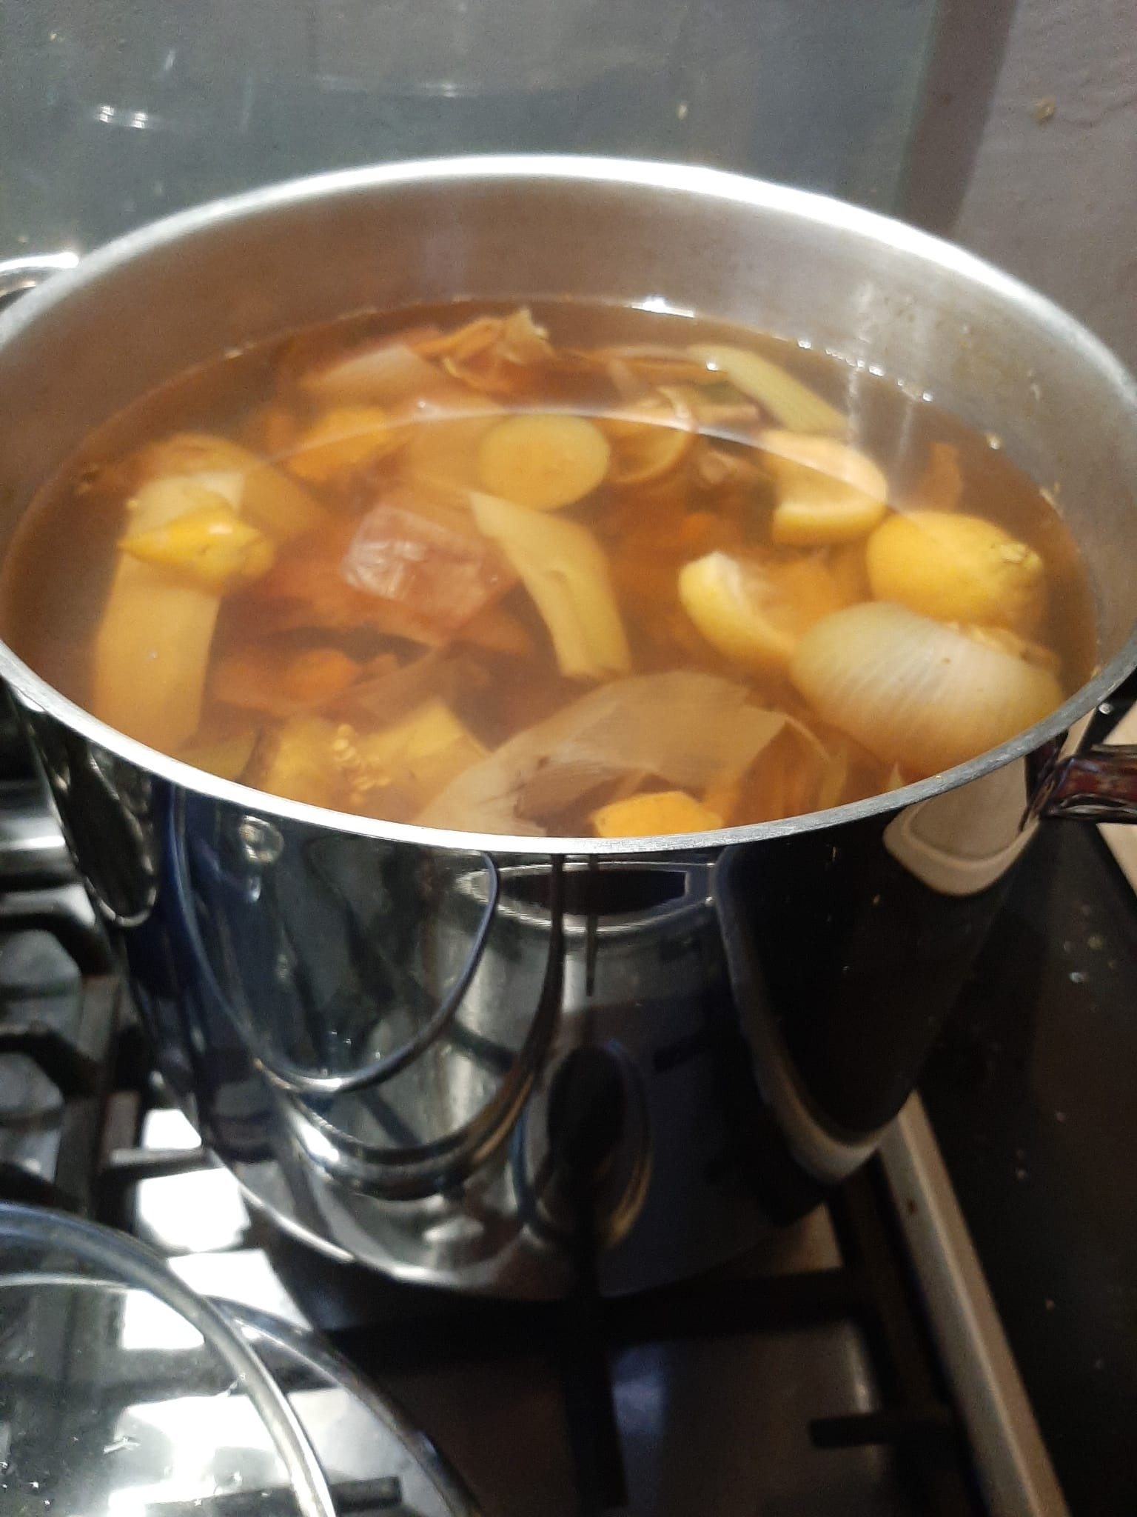
Nicola - 21:06 - Replying to Malcolm: “That’s what my folks do 😃”
I actually love it! We eat quite late as you can see so it works for us. I think it would be more difficult if we had kids...
Malcolm - 21:09 - Actually better. If eating late better today eat less
Malcolm - 21:09 - Better to***
Nicola - 22:09 - It's true. It works out for us.

21 July 2021
Nicola - 09:52 - Breakfast. Baked oatmeal with alpro vanilla and coffee.... ☕
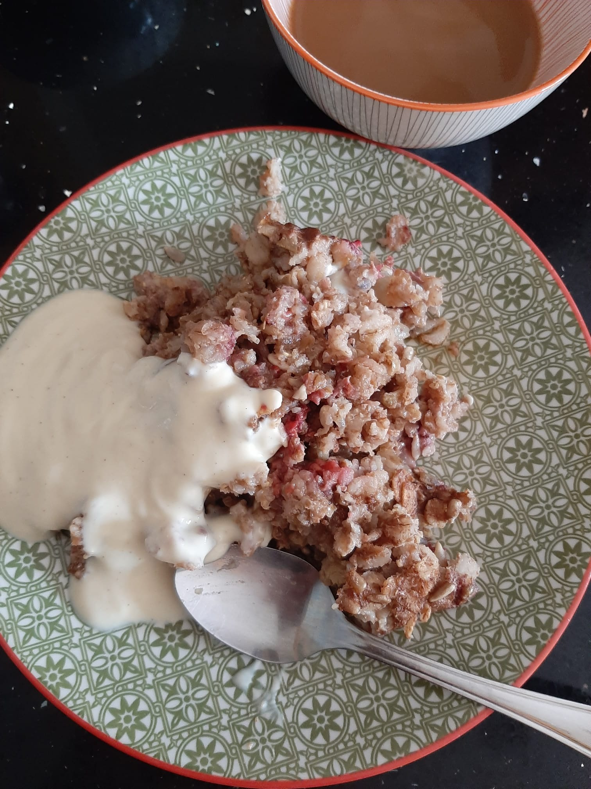
Michelle - 09:54 - You're all so healthy! I had chocolate spread on toast 😂
Beth - 09:54 - I keep meaning to photograph my other meals and then forget!

National Centre for Research Methods (NCRM)
Social Sciences
Murray Building (Bldg 58)
University of Southampton
Southampton SO17 1BJ
United Kingdom
Web www.ncrm.ac.uk
Email info@ncrm.ac.uk
Tel +44 23 8059 4539
Twitter @NCRMUK

